**ADAFRUIT PN532 BREAKOUT LIBRARY**

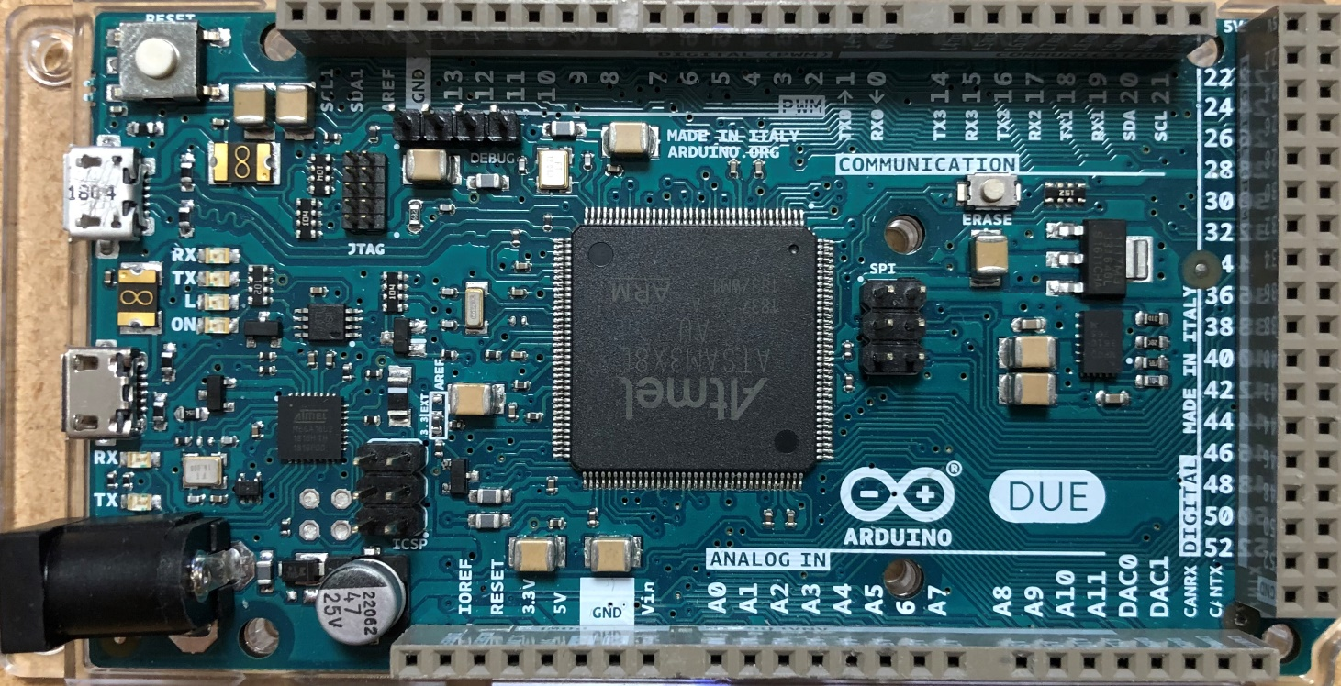Fully developed for Arduino Due. This library supports:  
Reading and writing NFC cards.

Conrolling the boards GPIO ports.

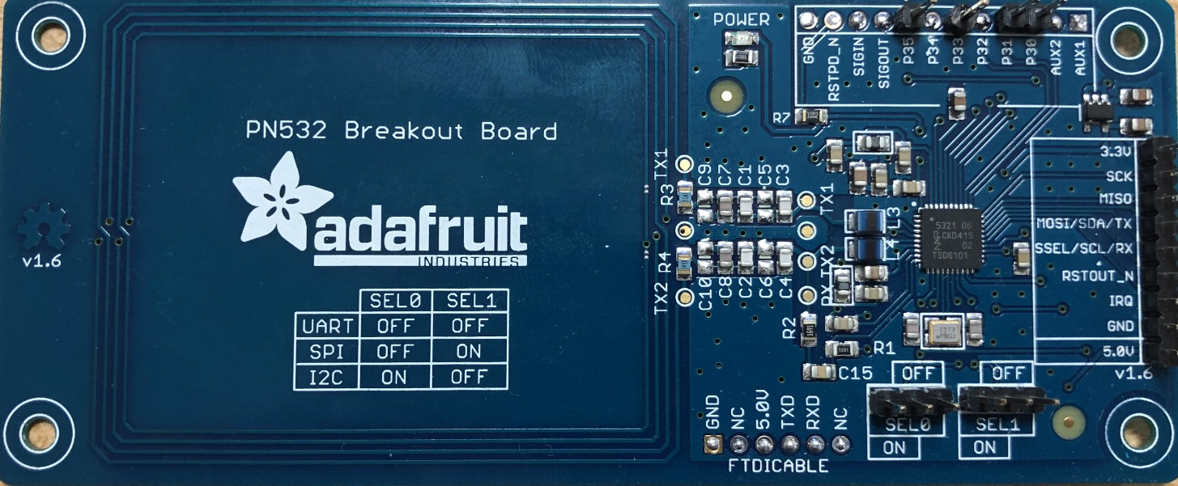Control with the I2C and SPI protocols.

IPASS project by: Mike Hoogendoorn

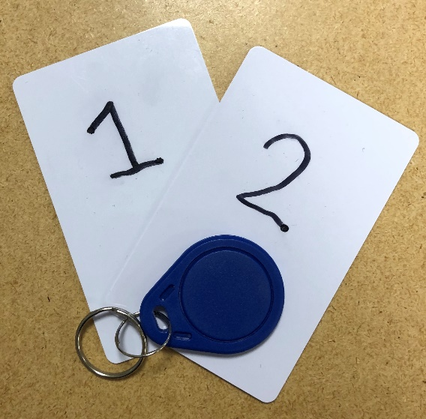Klas: TICT-TI-V1B Support for multiple types of NFC cards, stickers, keychains and more.

This library requires hwlib to function.